Joseph Silva Jr.

11/20/2021

SNHU

CS 499 – Journal 4-1: Career Choice and Artifact Update

**PART 1:**

* **Career Choice:**

With my career choice, I adding to my expertise by using my education in computer science as another step in my current career instead of starting a new career. I am combining my 10 years of law enforcement experience along with my computer science (CS) education to give myself more opportunities by joining the computer forensic teams (CFT) with the State of California. Even though I started my new job as a law enforcement for the State of California only 1 month ago, my new knowledge in CS has allowed me to have interviews with the Director of CA, Chief of Police, and the sergeants for CFT to join the CFT. Once I join the CFT, I will be given work experience and new knowledge in computer hardware and software to increase my expertise. My expertise will allow me to create reports for search warrants and assist California government. Besides my new career, I believe my next course of action will be to obtain a master’s degree in management for cyber security. The new degree will allow me to show that I am able to lead a team when it comes to the design of software and/or devices.

**Part 2:**

* **Software design/engineering**

My project uses many files from libraries and files to be brought into the main.cpp file to create the design. For example, the use of shaderfiles were used to develop the 3D design of the objects in the 3D world and without these shaderfiles the program will not run due to an GL error. In order to not lose track of these shaderfiles, I placed a folder into the main project to retrieve these files whenever they are needed, and they can be used by anyone who has the project. Along with the shaderfile folder, I also placed an image folder with my jpg and png files to retrieve the images needed to wrap the texture around the 3D designs.

One thing I changed from my original project; I added all my header files into the include directory of my project. Including these header files, allows the project to automatically retrieve the files without them being manually placed into the project within the sln for my project.

* **Algorithms and data structures**

I added new algorithms and data structures to my project to make the design better. With my design, I added new commands to the camera.h file to allow camera movement to up and down using the Q and E key on my keyboard by using the following commands with the GLFW library:

Main.cpp

Camera.h

Also, I added data structures such as staticMesh3D.cpp and h files along with vertextBufferObject.cpp and h files to give images in my 3D design better graphics. The following is an example comparing a design from an earlier design of my project with my new one:

Comparing the designs together, we can see the tile graphics are more realistic and more aligned in the newer version. We can also see the graphics on the duct tape and cellphone are a lot better as well when it comes to the shape and structure of it.

* **Databases**

1.

2.

3.

4.

5.

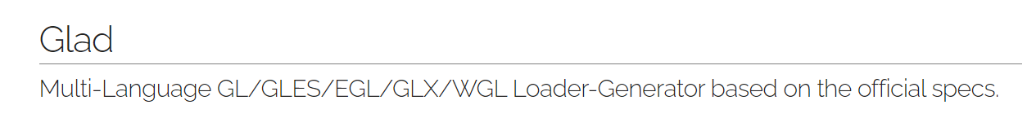

Theses databases have set libraries which allow the use of many dynamic link libraries. These libraries contain many files such as hpp, h, c, and cpp files. These files are then allowed to be used with many programs when developing code. With the use of visual studios 2022 and cMaker, I was able to link these library folders and include folders into my project. In visual studios, these libraries are necessary to allow the creation of .exe programs, the development of a window, and math to create a 3D world. Throughout the first weeks of my capstone, my glew32.lib became corrupt and it was causing havoc to my project by creating errors and failures. Due to these libraries being open sources, I was able to get the newest version of my libraries and link the new libraries to my project. With these new libraries, I was able to add new algorithms and data structures to make my project even better.